**MASTER IN DATA SCIENCE AND ADVANCED ANALYTICAL METHODS**

Reformulating Lisbon parishes

Tongjiuzhou Liu M20211012

**Supervisor:** Prof. Alberto Acedo Sanchez

Prof. Mijail Juanovich Naranjo Zolotov

**Introduction:**

In recent years, urban centers worldwide have experienced rapid transformations, necessitating the reassessment of administrative boundaries and structures to accommodate changing demographics and urban dynamics. The city of Lisbon is no exception, and in response to these challenges, the Portuguese government implemented administrative reforms in July 2012. The Parliament approved a proposal, including Chapter Two regarding the reconfiguration of Lisbon's parish map, which stipulated that the reconfiguration was based on the principles of territorial organization rationalization and adjustment, with the purpose of creating larger and more balanced parishes. The original 53 parishes were merged, modified, or maintained, and these changes took effect in January 2013. The implementation of Lisbon's administrative reform was a complex and challenging process, but it resulted in a more modern and efficient administrative structure for the city. Notably, the most modern and trendsetting parish, Parque das Nações, was born from this reform.

During the same period, the Portuguese National Institute of Statistics (INE) conducted the 2011 Portuguese National Census from March 21 to May 2011. Census enumerators collected data from households and individuals across the country. The INE was responsible for organizing and implementing the census, ensuring the accuracy of data collection and analysis. The comprehensive results and data from the census were gradually released starting on July 29, 2011. According to the census, Lisbon's population in 2011 was 547,733, a decrease from 564,477 in 2001, with a population density of approximately 6,378 people per square kilometer. Lisbon's population was aging, with a higher proportion of elderly people and a median age of around 42.2 years. Compared to other regions in Portugal, Lisbon had smaller average household sizes, with 2.4 people per household. Lisbon had a relatively high number of vacant housing units, accounting for about 12.2% of the total housing stock. The educational level of Lisbon's population was higher than that of other regions in Portugal, with a higher proportion of individuals completing higher education. The unemployment rate was higher than the national average, but the city also had a higher proportion of individuals engaged in professional, scientific, and technical activities. Lisbon had a diverse population, with a considerable proportion of foreign-born residents. The city attracted immigrants from various countries, particularly from African Portuguese-speaking countries, Brazil, and other European nations.

This study aims to propose a redistricting plan for the Lisbon administrative area based on a data-driven approach, utilizing the 2011 census data to inform the decision-making process. The objective of this research is to provide a comprehensive and well-informed redistricting proposal that takes into account the current and future needs of Lisbon's diverse population. By analyzing key demographic variables, such as population density, age distribution, education, employment, housing, and migration patterns, we seek to identify trends, disparities, and opportunities that can inform the redistricting process. In doing so, we aim to ensure that the proposed administrative boundaries are equitable, functional, and reflective of the city's changing demographics.

The study will commence with a meticulous examination of Lisbon's current administrative structure, followed by an analysis of the 2011 census data to underscore the patterns and trends that will inform the proposed redistricting plan. Subsequently, we will utilize advanced methods such as spatial cluster analysis from data science disciplines, regionalization studies, and other relevant tools to pinpoint Lisbon's specific challenges and opportunities at the granular level of the smallest geographical units. This will allow us to outline the goals and objectives of the redistricting process more effectively. Based on these findings, a comprehensive redistricting plan will be developed, with recommendations for redefining administrative boundaries, reallocating resources, and implementing new policies and plans to address the identified needs.

Once the initial redistricting plan is formulated using the 2011 census data, the latest 2021 census data will be employed to validate the results. By comparing the proposed plan with the most recent demographic data, we can ensure that the redistricting plan remains relevant and responsive to Lisbon's evolving needs. This validation process will allow us to refine the proposed plan, make adjustments where necessary, and ultimately create a more robust and effective administrative framework for the city.

In conclusion, the proposed redistricting plan for Lisbon's administrative area, based on a census data-driven approach, seeks to improve the city's governance and adapt it to the shifting needs of its population. By incorporating both the 2011 and 2021 census data and focusing on key demographic variables, we aim to develop a comprehensive, evidence-based proposal that addresses the challenges and opportunities faced by each administrative area. Ultimately, this research aims to contribute to the creation of a more equitable, functional, and responsive administrative framework that can better serve the diverse needs of Lisbon's residents, both now and in the future.

**Conceptual model:**

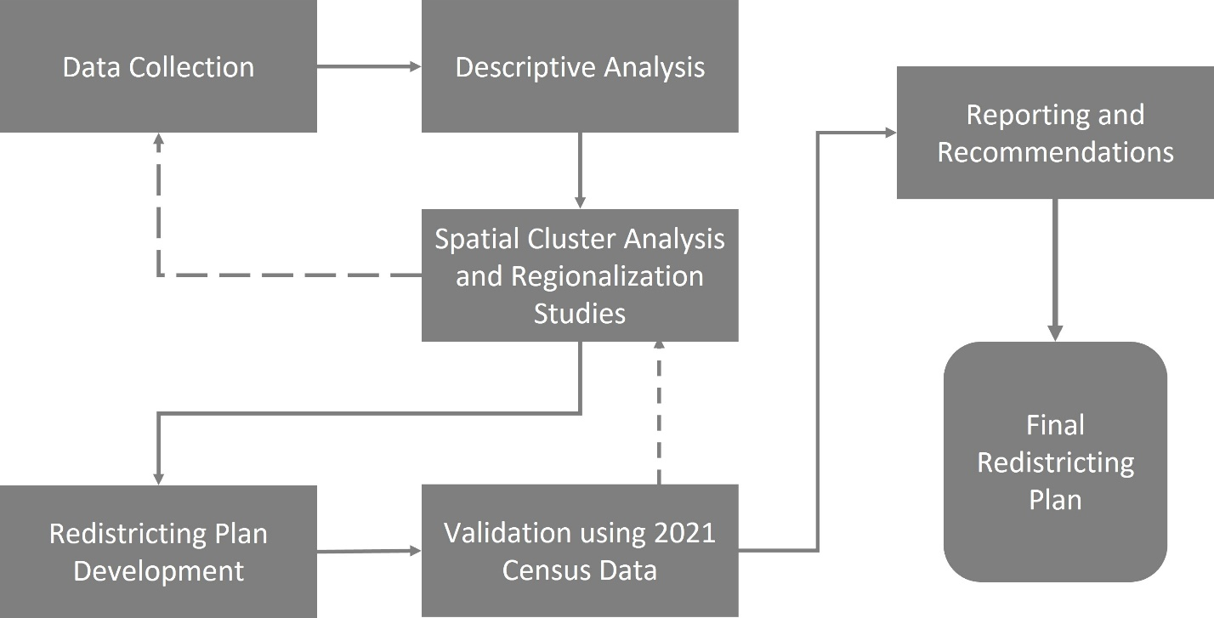

**Methodology:**

This study employs a mixed-methods approach, combining quantitative and qualitative data analysis techniques to develop a comprehensive redistricting plan for the Lisbon administrative area. The methodology is organized into several stages, as detailed below:

1. Data Preparation:

The primary data source for this research is the 2011 Portuguese National Census conducted by the Portuguese National Institute of Statistics (INE). The dataset will include variables such as population density, age distribution, education, employment, housing, and migration patterns. Before conducting any analysis, the raw census data will be preprocessed, cleaned, and transformed as needed to ensure its usability for the study. This process may include handling missing values, converting data types, and standardizing units of measurement. Additionally, the latest 2021 census data will be prepared to validate and update the initial redistricting plan.

1. Descriptive Analysis:

The descriptive analysis will involve calculating summary statistics for each demographic variable of interest, including means, medians, standard deviations, and ranges. Visualizations such as bar charts, histograms, and scatterplots will be created to illustrate the distribution and relationships between variables. Maps will be used to display the spatial distribution of key demographic variables across Lisbon's current administrative areas, highlighting areas of high or low concentration, as well as potential anomalies or outliers.

1. Spatial Cluster Analysis and Regionalization Studies:

Spatial cluster analysis techniques, such as k-means clustering and hierarchical clustering, will be employed to identify areas within Lisbon that share similar demographic characteristics. Geographic Information Systems (GIS) software will be used to visualize and analyze the spatial patterns of demographic variables and identify potential clusters. Regionalization studies, which involve aggregating smaller geographical units into larger, homogeneous regions, will be conducted using methods such as the Ward's method or the SKATER algorithm. This will enable the identification of potential new administrative boundaries that align with the observed demographic patterns.

1. Redistricting Plan Development:

The redistricting plan development will involve integrating the findings from the descriptive analysis and spatial cluster analysis to propose new administrative boundaries, resource allocations, and policies. Key considerations during this stage will include ensuring equitable representation, maintaining the integrity of communities, and facilitating efficient governance. Scenario analysis will be conducted to explore the potential implications of different redistricting options, and the proposed plan will be refined iteratively based on stakeholder input, feasibility assessments, and alignment with research objectives.

1. Validation using 2021 Census Data:

The validation process will involve comparing the initial redistricting plan, based on the 2011 census data, with the most recent 2021 census data. This comparison will help determine if the proposed administrative boundaries, resource allocations, and policies remain relevant and responsive to Lisbon's evolving needs. Discrepancies between the two datasets will be analyzed, and the redistricting plan will be updated accordingly. The validation process will also serve as a robustness check, ensuring that the proposed plan is adaptable to changing demographic trends.

1. Reporting and Recommendations:

The final stage of the methodology involves synthesizing the research findings, redistricting plan, and validation results into a comprehensive report. This report will provide a detailed account of the methodology, data sources, and analytical techniques used, as well as a summary of the key findings and proposed redistricting plan. Recommendations for implementing the proposed plan will be provided, including steps for engaging stakeholders, conducting public consultations, and integrating the new administrative boundaries into existing governance structures. The report will also offer suggestions for future research, such as exploring the impact of the redistricting plan on service provision, community cohesion, and political representation, as well as potential policy interventions to address the identified challenges and opportunities in each administrative area.

By following this expanded methodology, the study aims to develop a comprehensive, data-driven redistricting plan for the Lisbon administrative area that is responsive to the current and future needs of the city's diverse population, ultimately contributing to a more equitable, functional, and responsive administrative framework. This in-depth approach will help ensure that the redistricting plan is well-informed, evidence-based, and adaptable to changing circumstances.

Furthermore, the proposed methodology is designed to promote transparency and stakeholder engagement throughout the redistricting process. By actively involving key stakeholders, such as community leaders, policymakers, and residents, this research aims to foster a collaborative and inclusive approach to redistricting that takes into account diverse perspectives and needs.

In addition to the primary research objectives, this study can also serve as a model for other cities facing similar challenges related to urban growth, demographic shifts, and administrative restructuring. The methodology outlined here can be adapted and applied to different contexts, helping other urban centers develop data-driven redistricting plans that promote effective governance and equitable representation.

Overall, the expanded methodology outlined above will enable this study to develop a robust, evidence-based redistricting plan for Lisbon's administrative area. By considering a wide range of demographic variables, utilizing advanced data analysis techniques, and engaging stakeholders in the decision-making process, this research aims to create an administrative framework that can better serve the diverse needs of Lisbon's residents, both now and in the future.

**Questionnaire:**

|  |  |  |  |  |  |  |  |
| --- | --- | --- | --- | --- | --- | --- | --- |
| **Demographics:** | | | | | | | |
| **Residence in the parish** |  | **Occupation** |  | **Gender** |  | **Age** |  |
| **Familiarity and Opinions on the Current Administrative Structure:** | | | | | | | |
| **How familiar are you with Lisbon's current administrative boundaries?** |  | | | | | | |
| **Do you believe that the current administrative boundaries adequately represent the needs and interests of your parish/community?** |  | | | | | | |
| **Have you noticed any challenges or issues related to the current administrative structure in your parish/community?** |  | | | | | | |
| **Priorities for Redistricting:** | | | | | | | |
| **In your opinion, what should be the top priority when redistricting the Lisbon administrative area (e.g., equitable resource distribution, better representation, improved public services)?** |  | | | | | | |
| **What factors should be considered when redrawing administrative boundaries (e.g., population density, age distribution, housing, education, employment, migration patterns)?** |  | | | | | | |
| **Are there any specific concerns or needs in your parish/community that should be addressed during the redistricting process?** |  | | | | | | |
| **Involvement and Participation in the Redistricting Process:** | | | | | | | |
| **Have you been involved or would you like to be involved in the redistricting process in any capacity?** |  | | | | | | |
| **Do you believe that the redistricting process should be more transparent and inclusive, involving a greater number of community members and stakeholders?** |  | | | | | | |
| **Additional Comments:** | | | | | | | |
| **Please provide any additional comments, suggestions, or concerns related to the redistricting process in Lisbon.** |  | | | | | | |
| **Remember to include an introductory paragraph explaining the purpose of the questionnaire, ensuring participants' confidentiality, and providing instructions for completing the questionnaire.** |  | | | | | | |

.